AWS LAMBDA
Agenda
- Serverless Architectures
- Introduction to AWS Lambda
- Lambda Functions
- Key Characteristics of AWS Lambda
- Advantages of AWS Lambda
- Disadvantages of AWS Lambda
- Architecture of AWS Lambda
- Triggers in AWS Lambda
- AWS Lambda Dashboard
- Creating Lambda Function
Serverless Architectures:
- Serverless architecture allows developers to build and run applications without managing the underlying infrastructure.
- Servers are still used, but their management is handled entirely by the cloud provider.
- Developers focus on writing code, while the provider takes care of provisioning, scaling, and maintaining servers.
Features of Serverless:
- Event-Driven: Functions are triggered by events such as API calls, database updates, or file uploads.
- Scalable: Automatically scales up or down based on the workload.
- Pay-per-Use: Costs are based on the actual execution time and resources consumed.
- High Availability: Built-in fault tolerance and availability managed by the cloud provider.
Advantages of Serverless:
- No need to manage servers or infrastructure.
- Cost-effective for variable or unpredictable workloads.
- Faster development cycles with reduced operational overhead.
- Easy to integrate with other cloud services.
Disadvantages of Serverless:
- Vendor lock-in with specific cloud providers.
- Latency issues during cold starts (when functions are idle and need to initialize).
- Debugging and monitoring can be more complex due to distributed architecture.
Examples of Serverless Services:
- AWS Lambda: Executes code in response to events and automatically manages compute resources.
- Azure Functions, Google Cloud Functions, IBM Cloud Functions.
Introduction to AWS Lambda:
AWS Lambda is a serverless computing service offered by Amazon Web Services (AWS) that enables you to run code without managing servers. With Lambda, you simply write the code, upload it, and define the triggers. AWS handles all infrastructure management tasks like server provisioning, scaling, patching, and monitoring.
Lambda Functions:
AWS Lambda Functions are the core components of AWS Lambda, designed to execute your code in a serverless environment without the need to provision or manage servers. These functions are triggered by specific events, such as changes in an Amazon S3 bucket, updates in a DynamoDB table, or incoming HTTP requests through Amazon API Gateway.
When you upload the source code for a Lambda function (typically as a ZIP file), AWS automatically provides the necessary resources to run the function. Lambda functions are inherently scalable, automatically adjusting their capacity to meet demand, whether executing once or thousands of times per second.
These functions are commonly used for:
- Event-driven applications to process data from sources like S3 or DynamoDB.
- Automating backend workflows by connecting with other AWS services.
Key Characteristics of AWS Lambda:
- Event-Driven Execution
  - AWS Lambda is designed to execute code in response to specific events.
  - These events can originate from a wide range of AWS services or external triggers, including:
    - S3 Events: For example, a file upload to an S3 bucket can trigger a Lambda function.
    - Database Updates: DynamoDB Streams or changes in other AWS databases can trigger a Lambda function.
    - API Gateway: Lambda can be invoked by HTTP or HTTPS requests sent via Amazon API Gateway.
    - Scheduled Events: You can schedule Lambda functions to run at specific times using Amazon EventBridge (formerly CloudWatch Events).
    - Custom Events: Lambda can also process events sent directly from custom applications or third-party tools.
- Pay-As-You-Go Billing
  - AWS Lambda follows a consumption-based pricing model:
    - Invocation Charges: You pay for the number of function invocations.
    - Execution Duration: Billed based on the time your code runs, measured in milliseconds.
    - Provisioned Concurrency Costs: If you choose to pre-allocate a specific amount of concurrency to reduce cold start times, additional charges apply.
- Multi-Language Support
  - AWS Lambda supports a variety of programming languages, enabling developers to write functions in their preferred language:
    - Python
    - Node.js
    - Java
    - Go
    - Ruby
    - .NET (C#)
    - Custom Runtimes: For other languages, you can use the Lambda Runtime API to create custom runtimes.
- High Availability and Scalability
  - Lambda is built on AWS's highly available and scalable infrastructure.
  - Functions automatically scale by running instances in response to the number of incoming events, with no manual intervention required.
- Serverless Architecture
  - With Lambda, you don't need to provision or manage servers.
  - AWS handles all the infrastructure management, including capacity planning, patching, monitoring, and logging.
- Security and Access Control
  - Lambda functions run in isolated environments with a secure execution context.
  - Integrated with AWS Identity and Access Management (IAM) for fine-grained access control:
    - Control which AWS services and resources your function can access.
    - Assign execution roles with minimal permissions.
- Environment Variables
  - Lambda allows you to define environment variables to configure function behavior without modifying code.
  - Securely store sensitive information using AWS Key Management Service (KMS) for encryption.
- Cost Efficiency
  - Ideal for workloads with unpredictable or variable traffic patterns, as you only pay for what you use.
  - Reduces infrastructure costs by eliminating idle resource costs associated with traditional servers.
- Global Availability
  - AWS Lambda operates across multiple AWS regions and supports deployment to AWS Local Zones, AWS Outposts, and edge locations via Lambda@Edge for low-latency content delivery.
Advantages of AWS Lambda Functions:
- No Server Management: AWS Lambda handles the underlying infrastructure, allowing developers to focus solely on their code without worrying about server setup or maintenance.
- Automatic Scaling: Lambda functions scale automatically to handle requests, running in parallel and precisely adjusting to the workload.
- Event-Driven Execution: Functions can be triggered by events from various AWS services, such as uploading a file to an S3 bucket or updates in a DynamoDB table.
- High Availability: Lambda ensures high availability by scaling seamlessly during high traffic or demand, maintaining consistent performance.
- Cost-Effective: With a pay-per-use model, you are charged only for the execution time (measured in 100ms increments) and the number of function invocations. Idle code incurs no cost.
Disadvantages of AWS Lambda Functions:
- Cold Start Latency: When a Lambda function is idle for an extended period, initializing the environment can introduce a delay during the first execution, known as a "cold start."
- Limited Infrastructure Control: AWS manages the infrastructure, offering minimal control over the underlying resources and environment.
- Execution Time Limit: Functions have a maximum execution time of 15 minutes (900 seconds), which may not suffice for long-running tasks.
- Vendor Lock-In: Applications using Lambda are tied to AWS or similar cloud providers, potentially increasing dependency on a specific platform.
- Restricted Resource Configuration: Memory allocation ranges from 128 MB to 10 GB, with corresponding CPU power determined automatically, limiting flexibility in resource customization.
Use-Cases of AWS Lambda:
- Data Processing:
  - Process files uploaded to an S3 bucket, such as resizing images or transforming data formats.
  - Example: Generate thumbnails for images uploaded to an S3 bucket.
- Automation:
  - Automate tasks like database backups, log analysis, or event notifications.
  - Example: Trigger an alert when a specific event occurs in CloudWatch.
- Microservices:
  - Serve as individual components in a microservices architecture.
  - Example: Use Lambda to handle user authentication or process transactions in an e-commerce app.
- Real-Time Data Transformation:
  - Process and analyze data streams in real-time.
  - Example: Analyze clickstream data from a website using Kinesis and Lambda.
- Serverless API Backend:
  - Combine Lambda with API Gateway to build RESTful APIs.
  - Example: Create a serverless backend to handle HTTP requests for a mobile app.
- IoT Applications:
  - Trigger Lambda functions based on IoT device events.
  - Example: Process temperature sensor data and store it in a database.
Architecture of AWS Lambda (Event-Driven Architecture):
AWS Lambda operates based on an event-driven architecture, meaning it executes code in response to events triggered by AWS services or external sources.
How AWS Lambda Responds to Events:
- Lambda functions are invoked automatically when a specified event occurs.
- The function processes the event data, performs operations, and returns the output.
- Each invocation is independent and stateless.
Event Sources:
AWS Lambda integrates with various event sources, such as:
- Amazon S3: Triggers a function when objects are created, updated, or deleted in a bucket.
- Amazon DynamoDB: Processes data from DynamoDB Streams when changes occur.
- Amazon API Gateway: Invokes Lambda functions via HTTP/HTTPS requests.
- Amazon EventBridge (CloudWatch Events): Triggers functions on scheduled events or patterns.
- Amazon SNS: Executes functions in response to SNS notifications.
- Amazon SQS: Processes messages from SQS queues.
- Custom Applications: Send events directly to Lambda.
Stateless Nature of Lambda:
- Lambda functions are inherently stateless.
- Each function execution is isolated and has no access to the previous invocation's context or data.
- Persistent data storage must be implemented using external services like Amazon S3 or DynamoDB.
How Lambda Runs the Code:
A Lambda function consists of:
- Event Handler: Entry point of the function triggered by an event.
- Execution Context: The runtime environment where the function executes, including:
- CPU, memory allocation, and temporary storage (/tmp directory, up to 512 MB).
- Dependencies: The code and its libraries uploaded as part of the deployment package or container image.
- AWS Lambda sets up the execution environment, invokes the function, and cleans up after execution.
Cold Starts and Warm Starts:
  - Occurs when a function is invoked for the first time or after a period of inactivity.
  - AWS creates a new execution environment, downloads the function code, and initializes it.
  - Results in higher latency during the initial invocation.
  - Happens when an already-initialized execution environment is reused.
  - Reduces latency as the environment is pre-warmed and ready to execute the code.
  - Cold starts can lead to noticeable delays for latency-sensitive applications.
  - Techniques to mitigate cold starts:
    - Use provisioned concurrency to keep environments pre-warmed.
    - Optimize function initialization by reducing package size and external dependencies.
Impact on Performance:
Warm Start:
Cold Start:
Triggers in AWS Lambda:
AWS Lambda integrates with a variety of services that can trigger a Lambda function to execute. These triggers enable Lambda to respond to specific events or conditions. Below is a detailed list of the types of triggers in AWS Lambda:
1. S3 (Simple Storage Service) Triggers
- Trigger Lambda functions when events occur in an S3 bucket, such as object uploads, deletions, or modifications.
- Examples:
  - Automatically process and resize images uploaded to S3.
  - Parse and store data from CSV files uploaded to S3.
2. DynamoDB Triggers
- Trigger Lambda functions when changes occur in a DynamoDB table (Insert, Update, or Delete).
- Examples:
  - Real-time synchronization of data to another database or system.
  - Logging database changes for audit purposes.
3. Amazon SQS (Simple Queue Service) Triggers
- Trigger Lambda functions to process messages in an SQS queue.
- Examples:
  - Handle order processing workflows.
  - Process batched or queued tasks from distributed systems.
4. Amazon SNS (Simple Notification Service) Triggers
- Trigger Lambda functions when messages are published to an SNS topic.
- Examples:
  - Send real-time notifications or alerts via email/SMS.
  - Perform additional processing based on received notifications.
5. API Gateway Triggers
- Use API Gateway to trigger Lambda functions in response to HTTP or REST API requests.
- Examples:
  - Build serverless web backends or microservices.
  - Handle API requests for user authentication or data processing.
6. Amazon Kinesis Triggers
- Process real-time streaming data using Lambda functions.
- Examples:
  - Analyze real-time sensor data from IoT devices.
  - Process clickstream data from websites or applications.
7. CloudWatch Events (EventBridge) Triggers
- Trigger Lambda functions based on system events or schedules.
- Examples:
  - Automate tasks like cleaning up unused resources.
  - Trigger functions on a schedule (e.g., hourly, daily, or weekly).
8. CloudWatch Logs Triggers
- Trigger Lambda functions when logs are generated in CloudWatch.
- Examples:
  - Process and analyze logs for troubleshooting.
  - Send alerts for specific log events (e.g., error messages).
9. AWS Step Functions
- Use Step Functions to trigger Lambda functions as part of a state machine workflow.
- Examples:
  - Orchestrate multi-step processes, such as order fulfillment or video encoding workflows.
10. Amazon Cognito Triggers
- Trigger Lambda functions for authentication and authorization workflows in Amazon Cognito.
- Examples:
  - Validate or customize sign-up and sign-in flows.
  - Add additional user data during the registration process.
11. IoT Core Triggers
- Trigger Lambda functions based on IoT events or device messages.
- Examples:
  - Process telemetry data from connected IoT devices.
  - Trigger actions like turning on a device or sending alerts.
12. CodeCommit Triggers
- Trigger Lambda functions when changes are made to a repository in AWS CodeCommit.
- Examples:
  - Automate CI/CD pipelines.
  - Send notifications for repository updates.
13. CloudFormation Custom Resources
- Trigger Lambda functions to handle custom logic in AWS CloudFormation templates.
- Examples:
  - Automate the creation of resources not directly supported in CloudFormation.
  - Perform validations during template execution.
14. Elastic Load Balancer (ALB) Triggers
- Use Application Load Balancer to trigger Lambda functions for HTTP/HTTPS requests.
- Examples:
  - Build serverless web applications.
  - Handle web requests directly via Lambda.
15. RDS Proxy Triggers
- Trigger Lambda functions through database proxies to interact with relational databases.
- Examples:
  - Perform database queries or updates in response to application needs.
16. Third-Party and Custom Event Triggers
- Use third-party applications or custom events to invoke Lambda functions via APIs.
- Examples:
  - Integrate with external systems for processing data.
  - Trigger Lambda using custom events published to EventBridge.
Components of AWS Lambda:
1. AWS Lambda Function
- Core Component: The Lambda function itself is the code you write and deploy. It contains the logic that will be executed in response to an event or trigger.
- Code Deployment: The function's code can be deployed using different methods, such as uploading a ZIP file, using AWS Lambda layers, or through container images.
- Languages Supported: Lambda supports various runtime environments, including popular programming languages like Python, Java, JavaScript (Node.js), Go, C#, Ruby, and custom runtimes.
2. Runtime Environment
- Supported Runtimes: AWS Lambda supports several programming languages, including:
  - Python
  - Node.js
  - Java
  - Go
  - Ruby
  - C#
  - Custom Runtimes (via AWS Lambda's custom runtime API)
- Runtime Management: AWS Lambda manages the runtime environment automatically, including updating and patching, allowing developers to focus on their code instead of the environment.
3. Function Configuration
- Memory Allocation: AWS Lambda allows you to specify the amount of memory your function requires (from 128 MB to 10 GB). Memory size affects CPU power and execution performance.
- Timeout: Lambda functions have a maximum execution time of 15 minutes (900 seconds). You can set this limit according to the expected runtime of the function. If the function exceeds this time, it is terminated.
- Concurrency: You can define the concurrency for the function, which specifies how many instances of the function can run simultaneously. Lambda allows for burst scaling and automatic adjustment to traffic demands.
- Timeout and Memory Optimization: Proper memory allocation can reduce execution time by allocating enough CPU power. Optimizing memory settings can lead to more efficient functions, faster processing, and reduced costs.
4. Execution Role (IAM Role)
- IAM (Identity and Access Management): Every Lambda function is associated with an execution role. This role grants the Lambda function the necessary permissions to interact with other AWS services like S3, DynamoDB, CloudWatch, and more.
- Policy Attachment: The IAM role attached to the Lambda function specifies the AWS services and resources it can access. It can have permissions defined by AWS managed policies or custom policies.
- Security: The role ensures that Lambda functions follow the principle of least privilege by allowing only the required permissions, preventing unauthorized access.
5. Event Sources
- Triggers: Lambda functions are typically triggered by specific AWS events. Event sources can include:
  - Amazon S3 (e.g., file uploads)
  - DynamoDB (e.g., table updates)
  - API Gateway (e.g., HTTP requests)
  - CloudWatch (e.g., scheduled events)
  - AWS SNS (Simple Notification Service)
  - AWS SQS (Simple Queue Service)
- Event Data: Lambda receives data from event sources, which can include file metadata, request parameters, or any other relevant data. The function processes this data and can respond accordingly.
6. Environment Variables
- Dynamic Configuration: Lambda functions allow you to define environment variables that can be accessed by your function at runtime. This enables you to store sensitive or configuration data like database credentials, API keys, and other configuration values.
- Key-Value Pairs: Environment variables are stored as key-value pairs. They can be updated without requiring redeployment of the Lambda function.
AWS Lambda Dashboard:
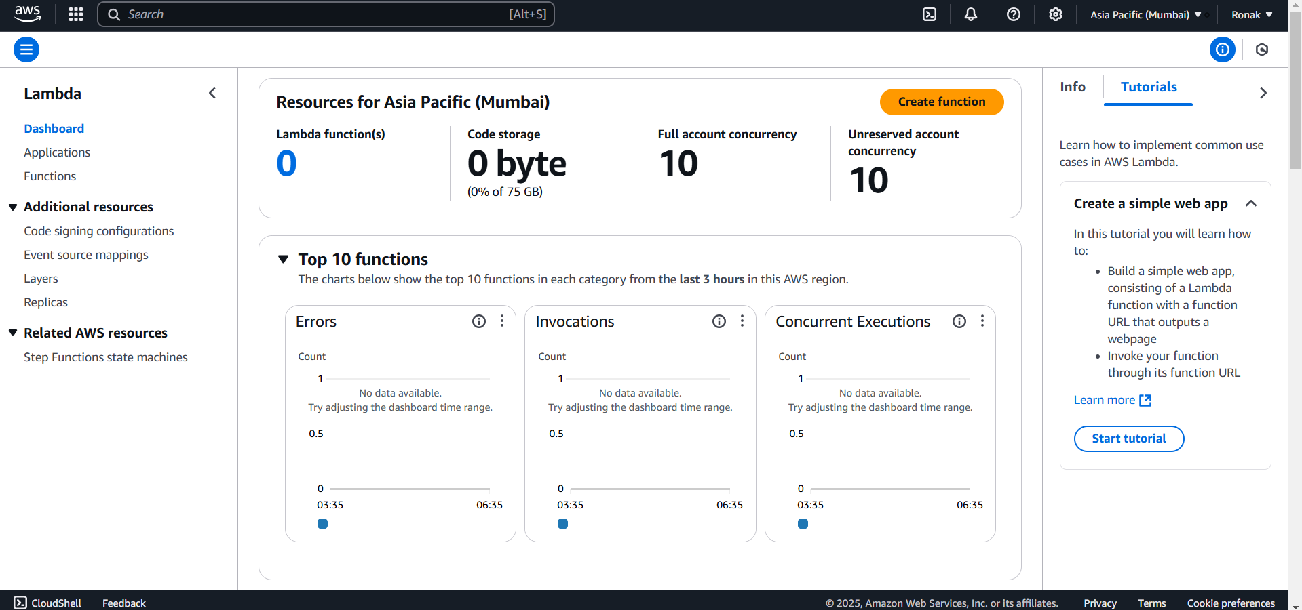
Features of the AWS Lambda Dashboard:
- Resource Summary (Top Section):
  - Lambda Function(s): Displays the total number of Lambda functions created in the selected AWS region (e.g., Asia Pacific - Mumbai in this case).
  - Code Storage: Shows the amount of storage being used by your Lambda functions, out of the maximum allowed limit (75 GB per account).
  - Concurrency:
    - Full Account Concurrency: Maximum number of concurrent executions allowed for all functions.
    - Unreserved Account Concurrency: Remaining concurrency available after reserved limits for specific functions.
- Create Function Button:
  - Allows you to create a new Lambda function by defining its runtime, permissions, and trigger events. Clicking on this leads to the configuration page for Lambda functions.
- Top 10 Functions Monitoring (Charts):
  - Errors: Displays the number of errors encountered by Lambda functions in the past three hours.
  - Invocations: Tracks the number of times Lambda functions were invoked during the same period.
  - Concurrent Executions: Shows how many functions were running simultaneously at any given point.
  - These charts help monitor function performance and diagnose potential issues.
- Navigation Panel (Left Sidebar):
  - Applications: Provides an overview of applications that use multiple AWS services, including Lambda.
  - Functions: Lists all the Lambda functions you have created, allowing you to manage and edit them.
  - Additional Resources:
    - Code Signing Configurations: Secure your functions by verifying the source of the code package.
    - Event Source Mappings: Configure triggers (e.g., S3, DynamoDB) for Lambda functions.
    - Layers: Reuse code libraries across multiple Lambda functions to save space and effort.
    - Replicas: Manage multiple versions or aliases of your Lambda function.
- Related AWS Resources:
  - Step Functions State Machines: Integrate with AWS Step Functions for orchestrating workflows involving multiple Lambda functions.
- Tutorial Section (Right Sidebar):
  - Provides guidance to learn and implement common use cases, such as creating a simple web application using AWS Lambda.
  - Includes a Start Tutorial button that walks users through step-by-step Lambda setups.
- Region Selector (Top-Right Corner):
  - Allows you to change the AWS region for your Lambda functions, as AWS resources are region-specific.
- Search Bar:
  - Quickly search for functions, configurations, or documentation within the AWS Lambda service.
Creating Lambda Function:
Step 1: Search Lambda and open it.
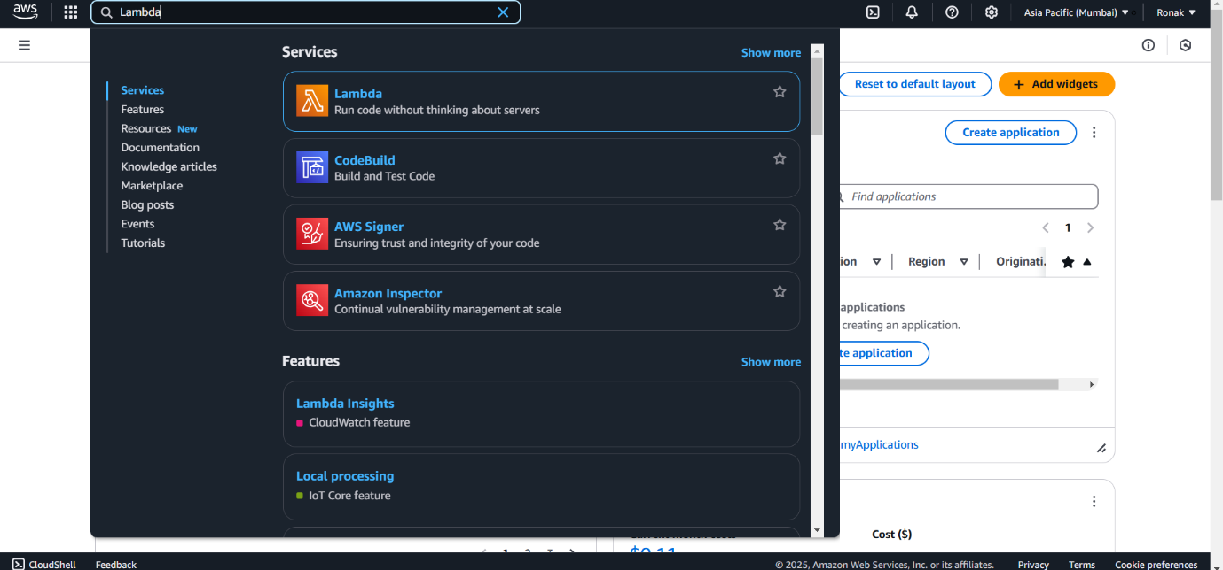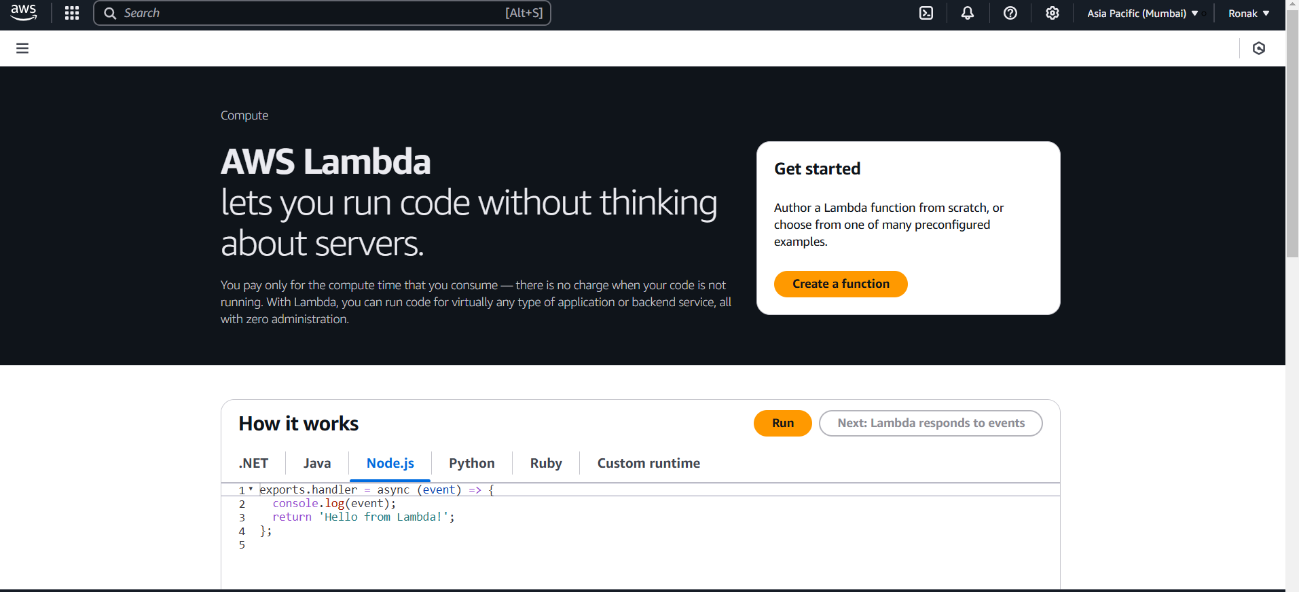
Step 2: Now, to create a Lambda Function click on Create Function option.
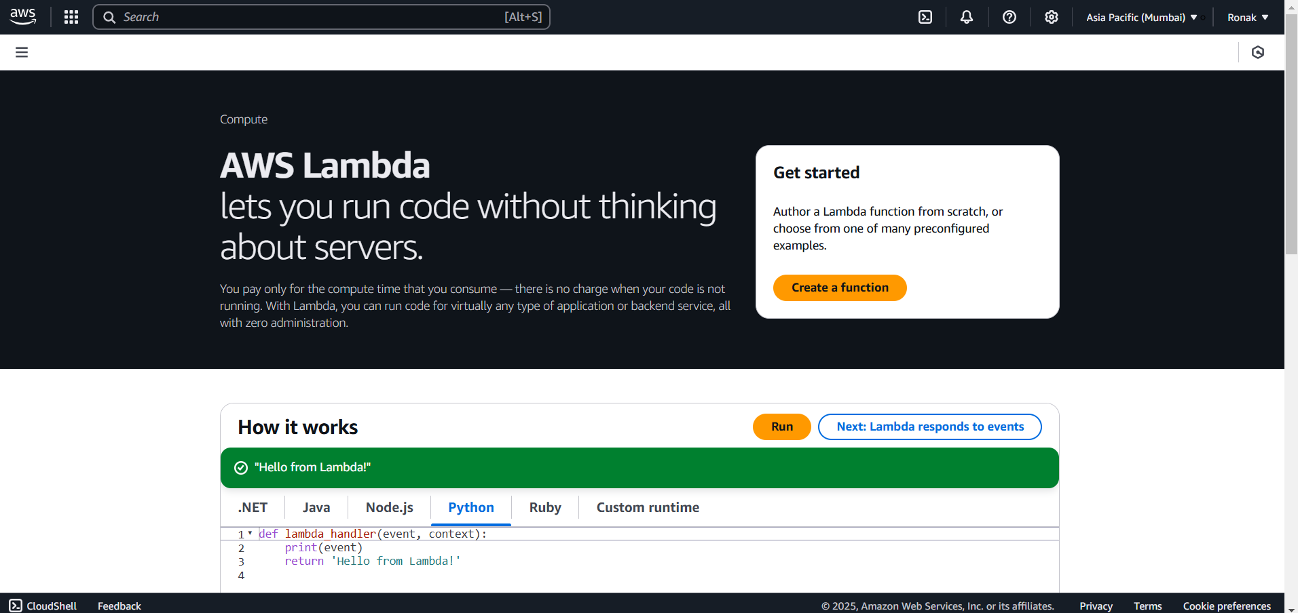
Step 3: Select Author from Scratch option, now all the system settings, memory allocation will be run by function itself.
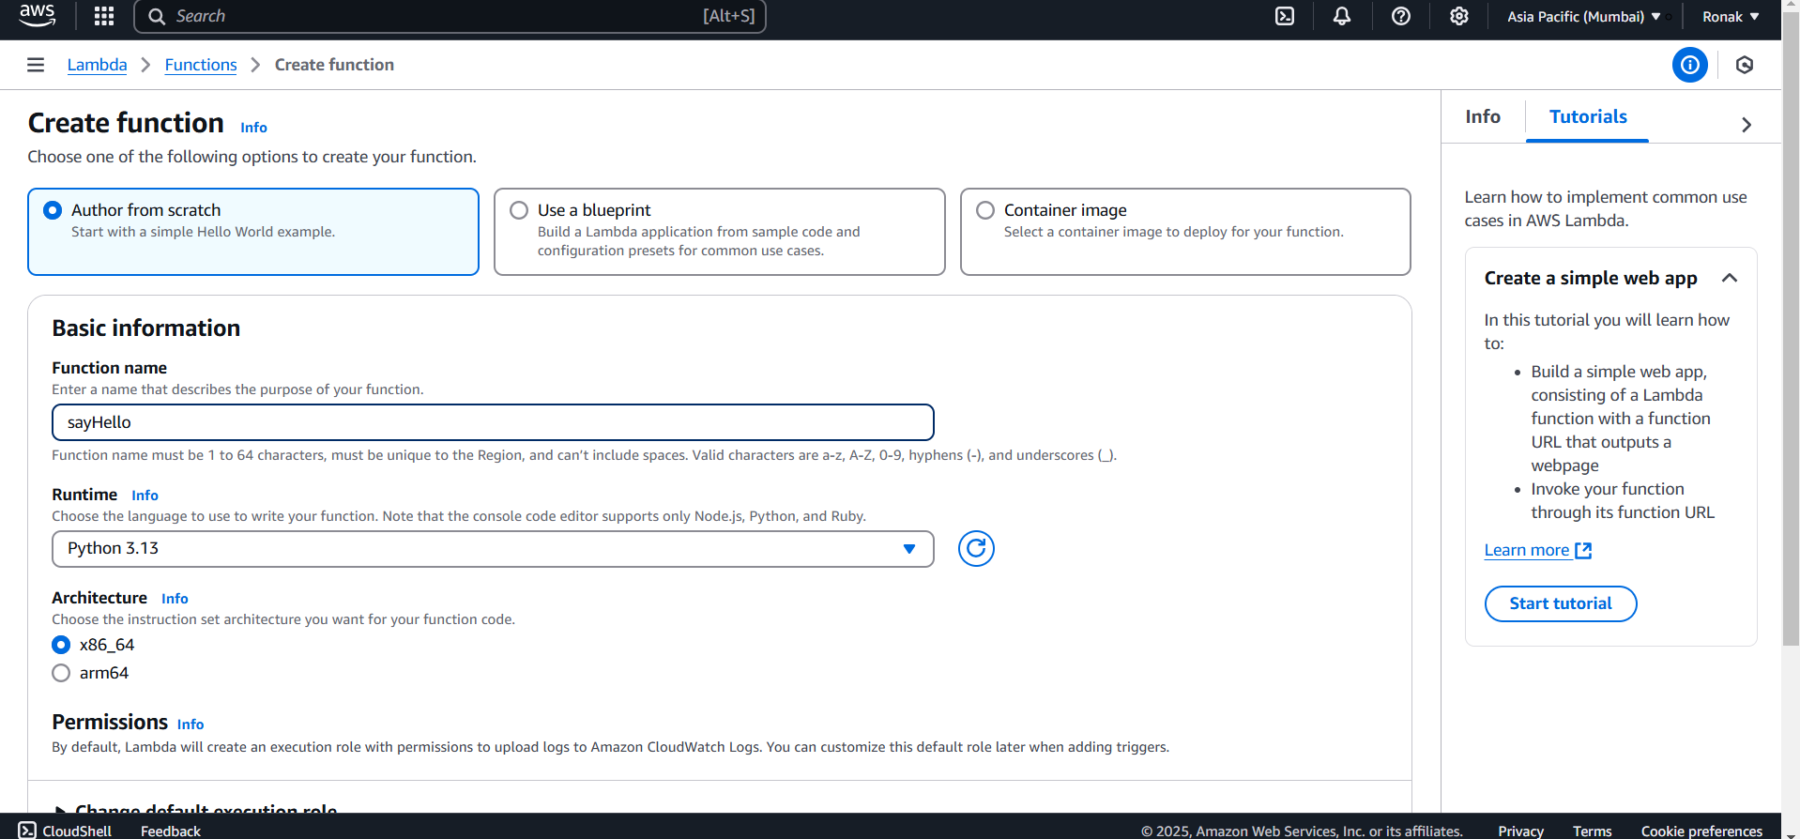
Step 4: Now, the function is created
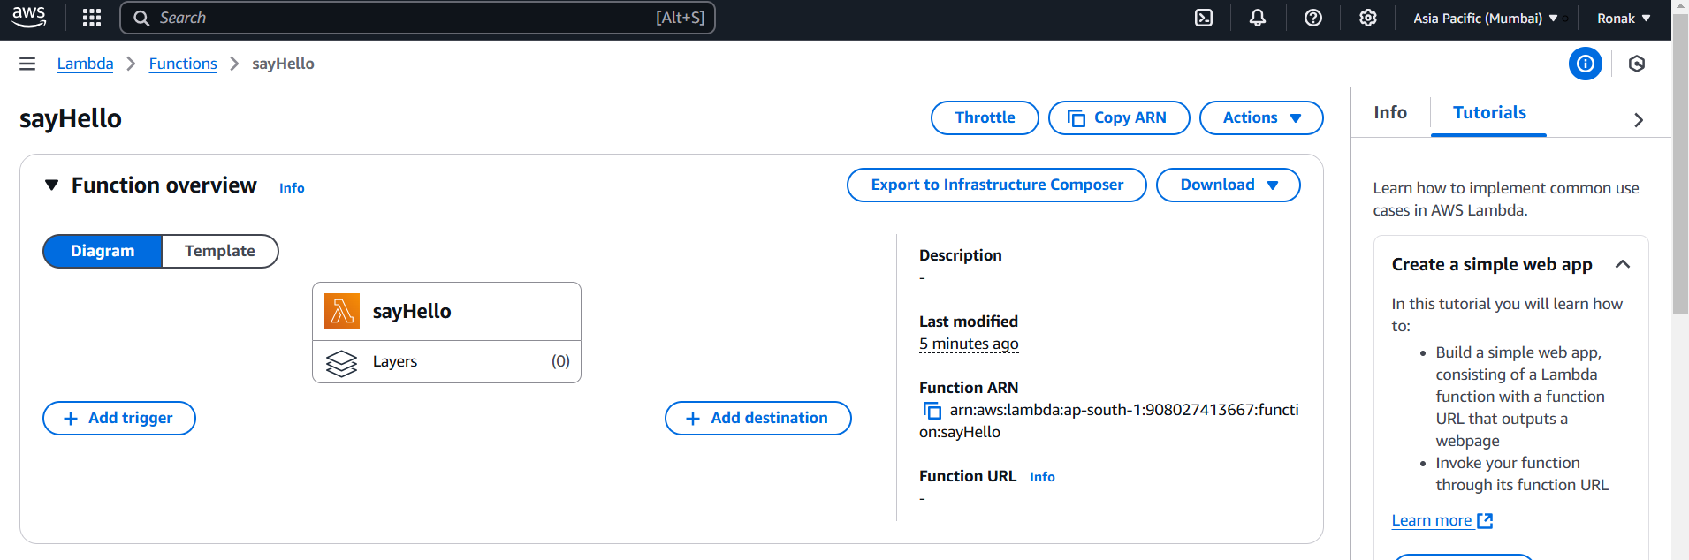
Step 5: Now, go to Code option
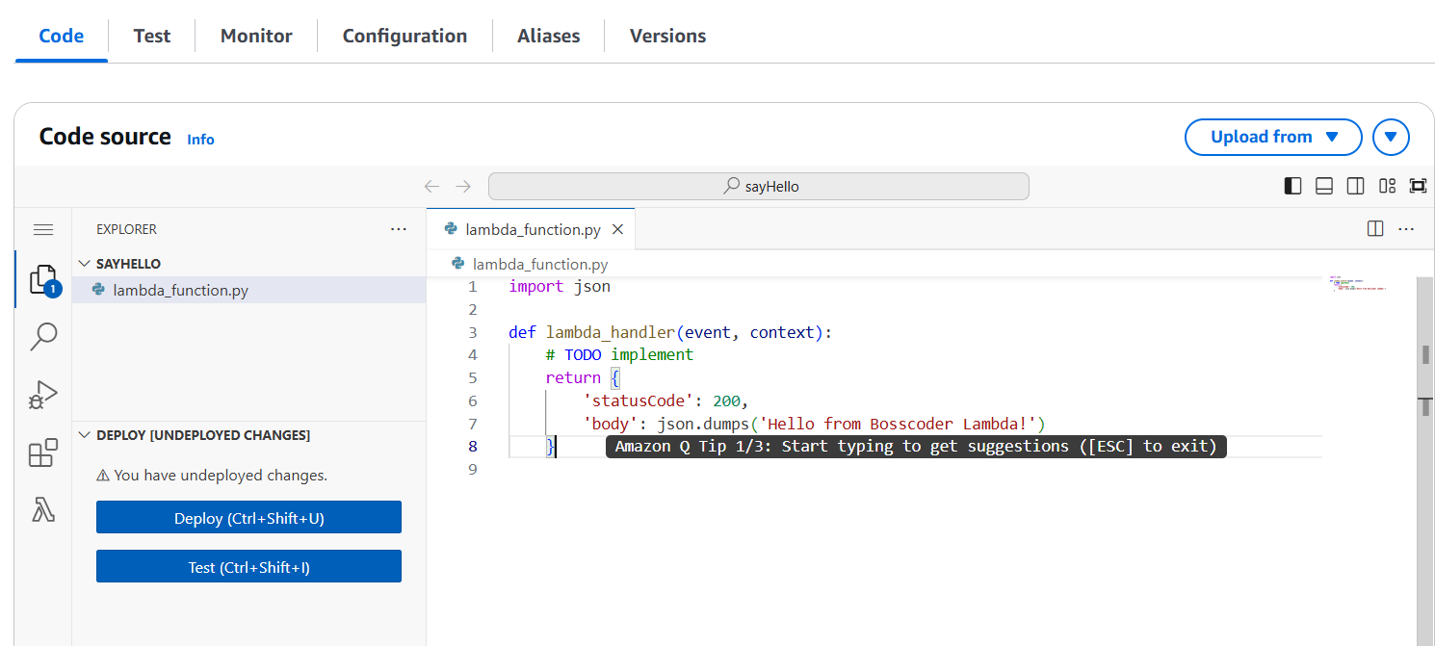
Step 6: You can test as well as deploy this function as this function will be deployed and you will not get to know how this is deployed as this is serverless.
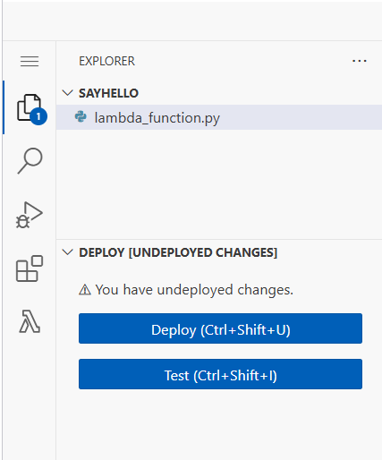
Step 7: Now, the code is formed and deployed but to use it we need to set up Triggers after that one URL will be generated so that this function can be used for the Add Triggers option above and select trigger for example: API Gateway.
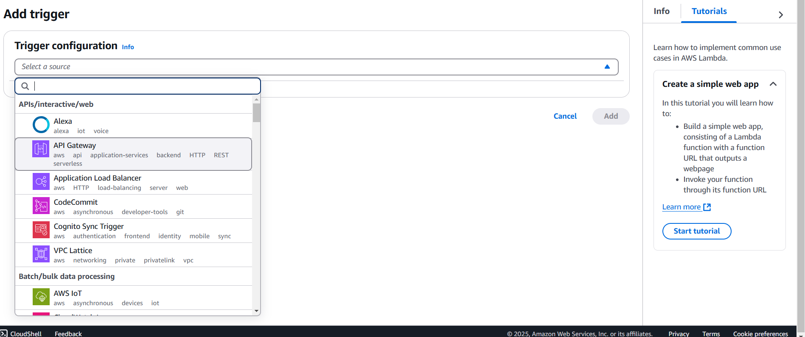
Step 8: Now, select the options and click on Add.
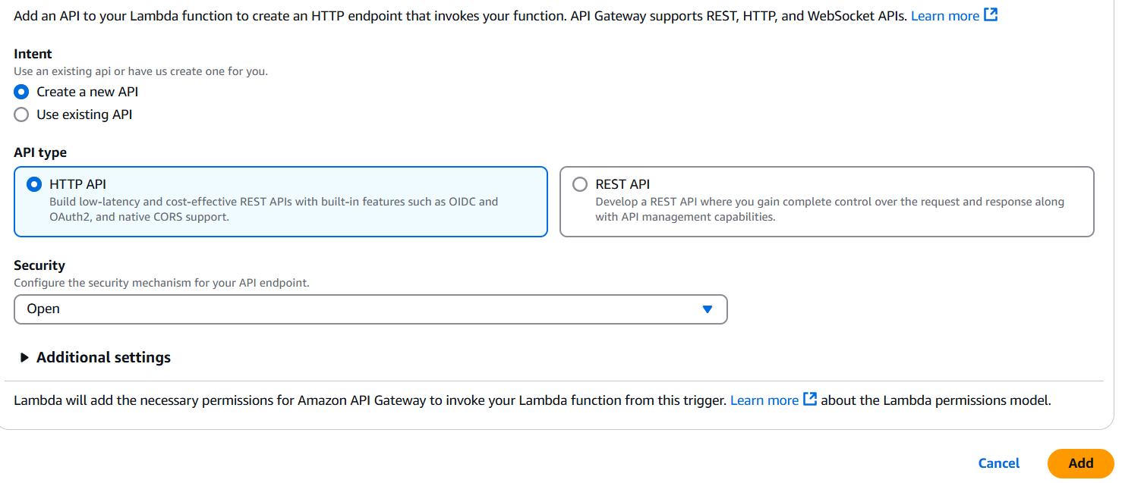
Step 9: Now, the trigger is added.

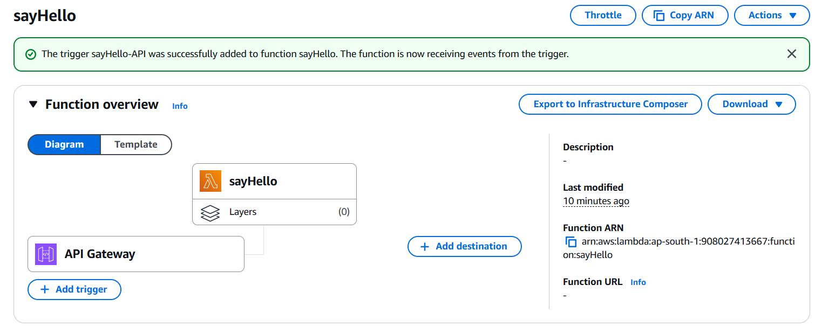
Step 10: And now go below to Configuration and your API Gateway will be there and you will also the endpoint there.
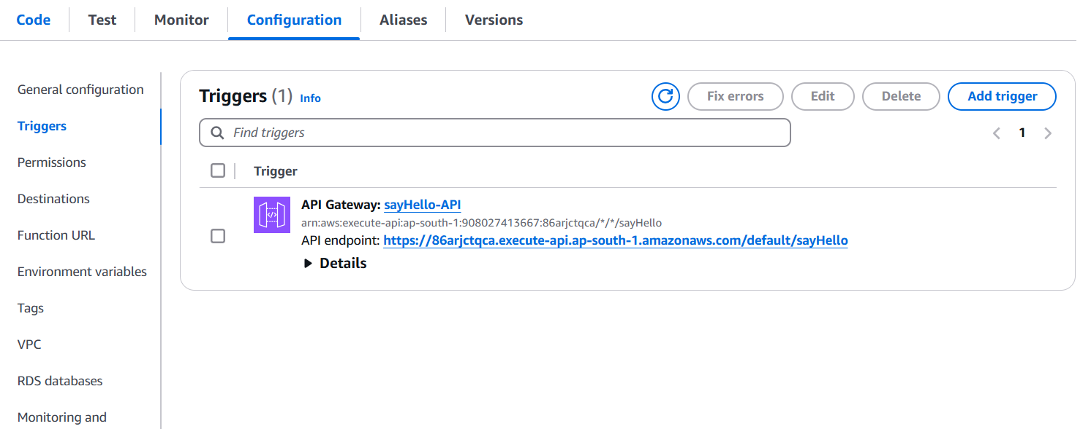
Step 11: Now, copy the link and paste in the next tab and you will see the output and as per the change in code you will get a different output and a lambda function is generated.
